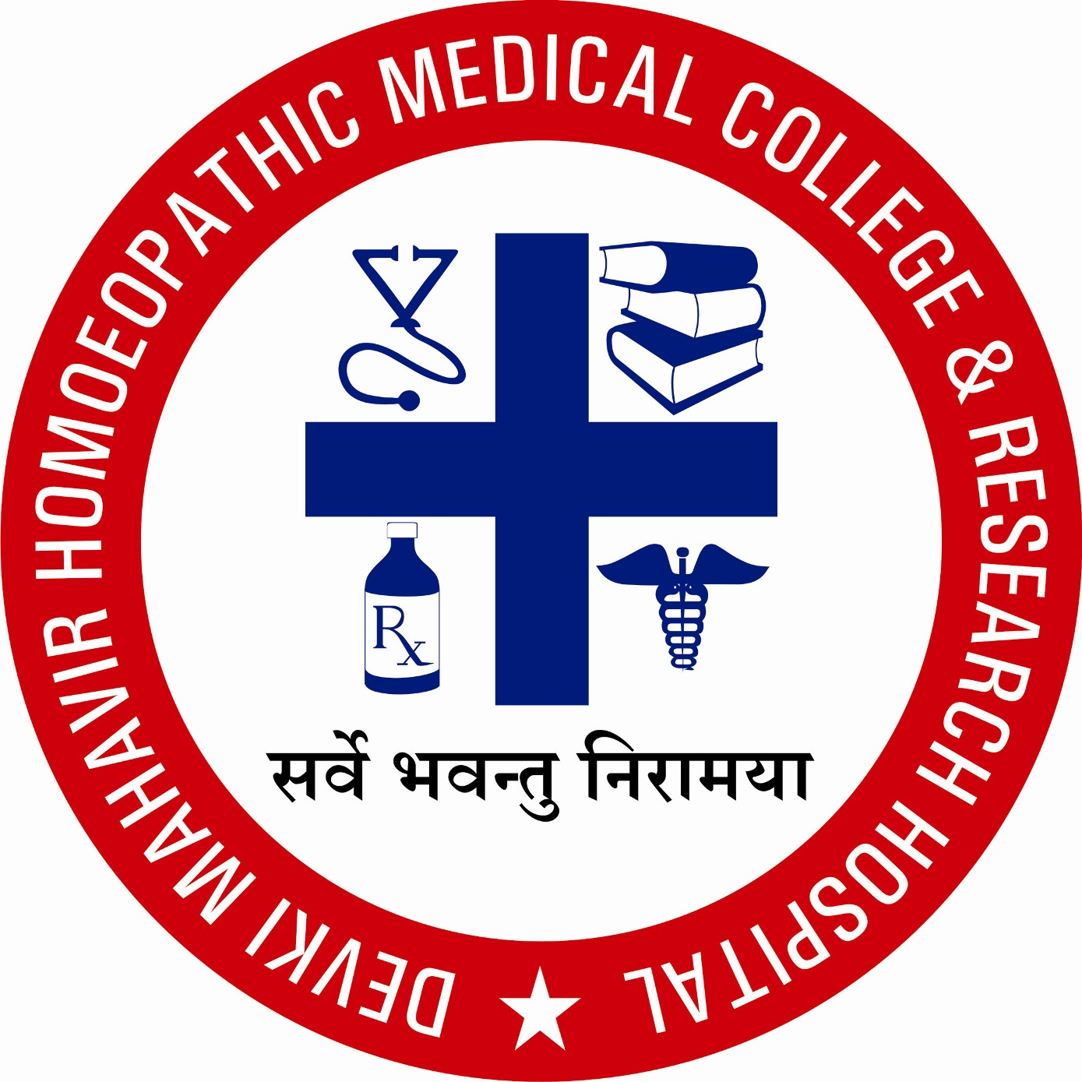
DEVKI MAHAVEER HOMOEOPATHIC MEDICAL COLLEGE & RESEARCH HOSPITAL
(Run under – Vananchal Educational & Welfare Trust®)
Approved by Dept of AYUSH, Govt. of India, New Delhi
Permanent Affiliated to Vinoba Bhave University, Hazaribag, Jharkhand
Farathiya, Garhwa, Jharkhand 822114
Ph. no. – 06561-254555 Fax no. -06561-299001, Email-dmhmcrh_garhwa@rediffmail.com
Website www.vananchaltrust.org

4-1-2 List of Sports and Cultural Activities- Photographs

- Following Game Are provided by the Institution.

OUTDOOR GAMES
- CRICKET
- FOOTBALL
- VOLLYBALL
- BADMINTON
- LONG TANNIS
INDOOR GAMES
- CARROM BOARD
- LUDO
- TABLE TENNIS
- SNOOKER

ANNUAL SPORTS & PRIZE DISTRIBUTION
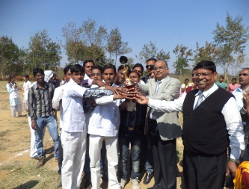
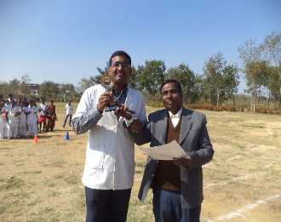
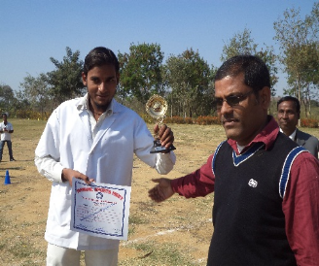

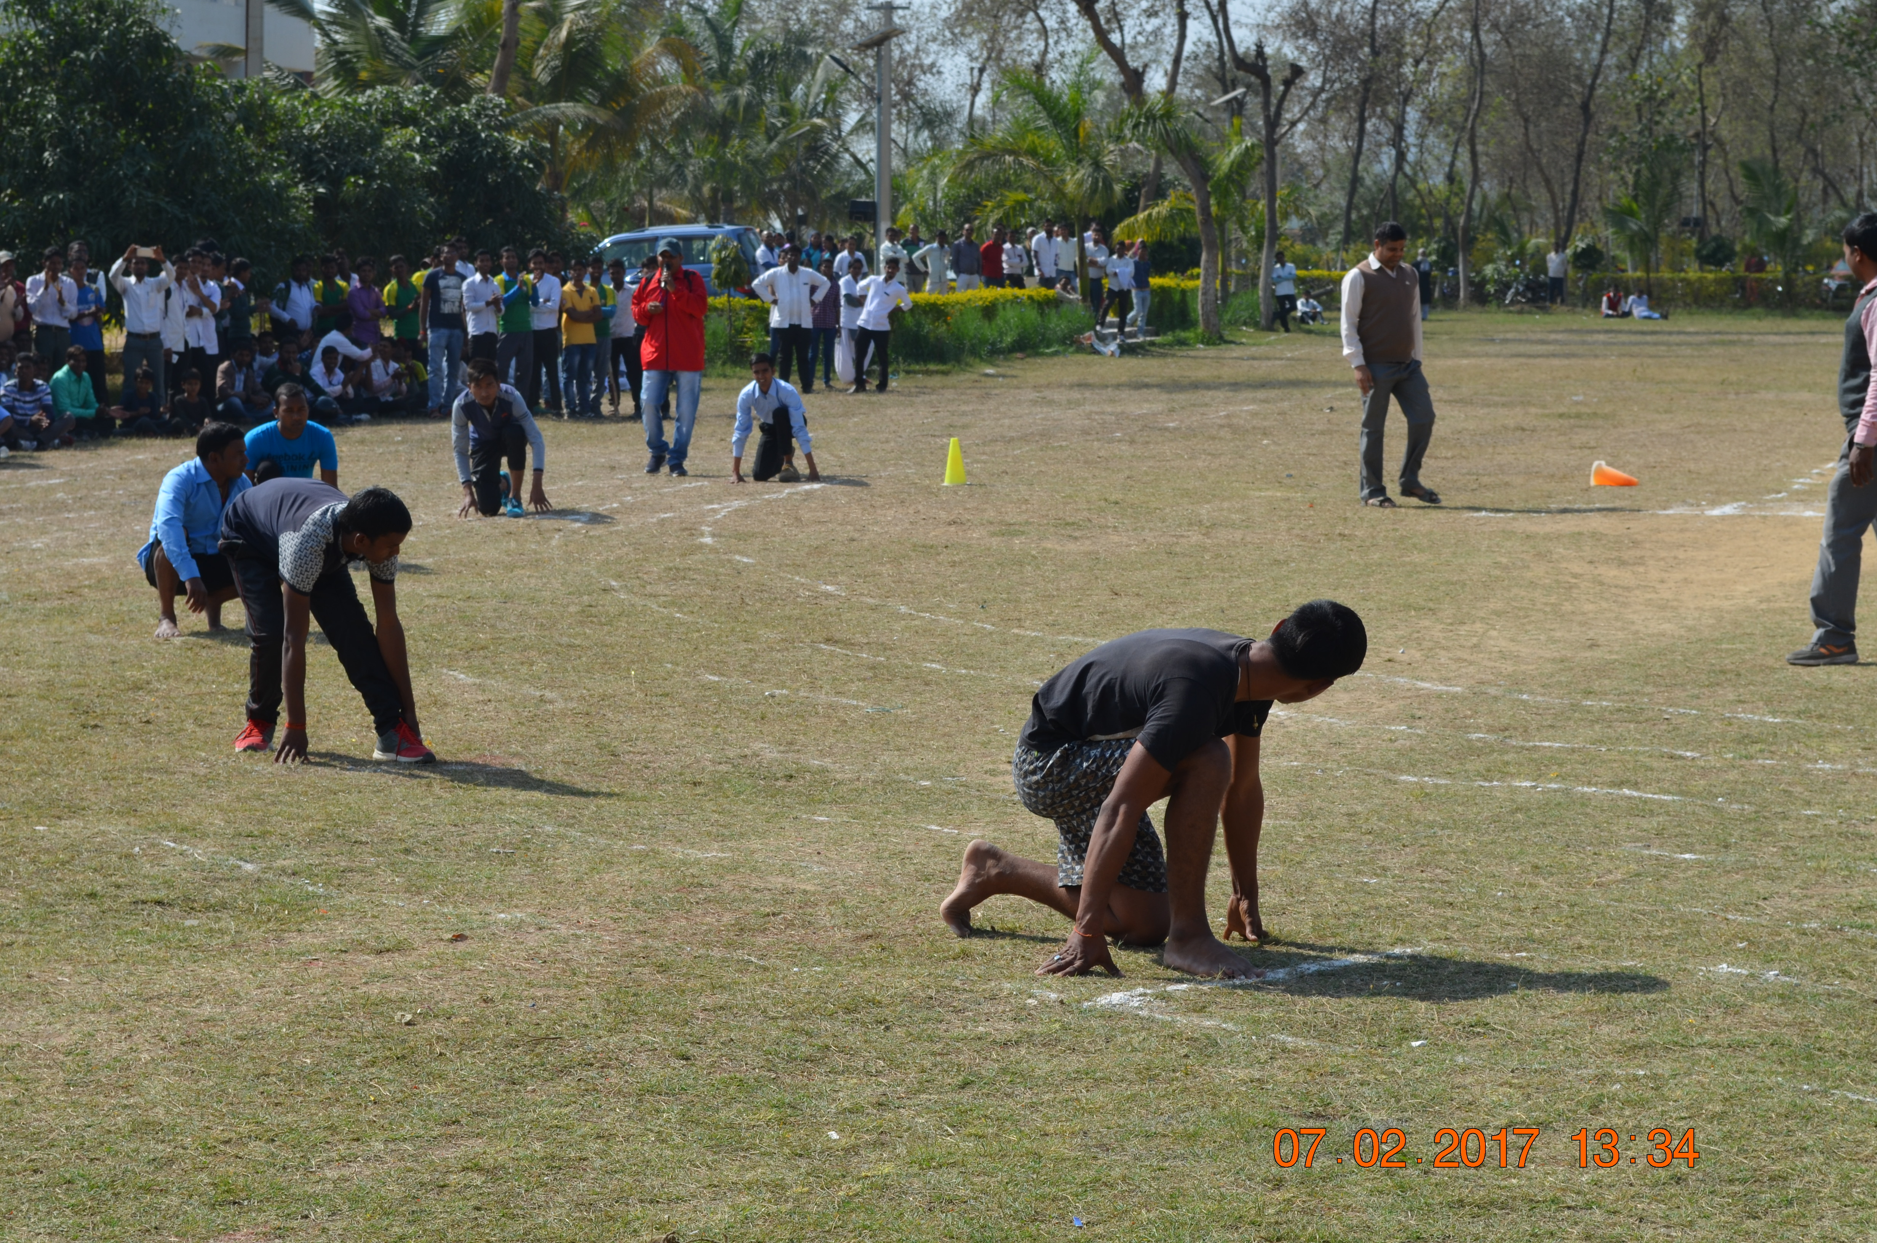

CULTURAL ACTIVITIES IN CORPORATE WITH VANANCHAL EDUCATIONAL AND WELFARE TRUST

- Hahnemann Jayanti
- Doctors meet events
- Teachers Day
- Sarswati Puja Event

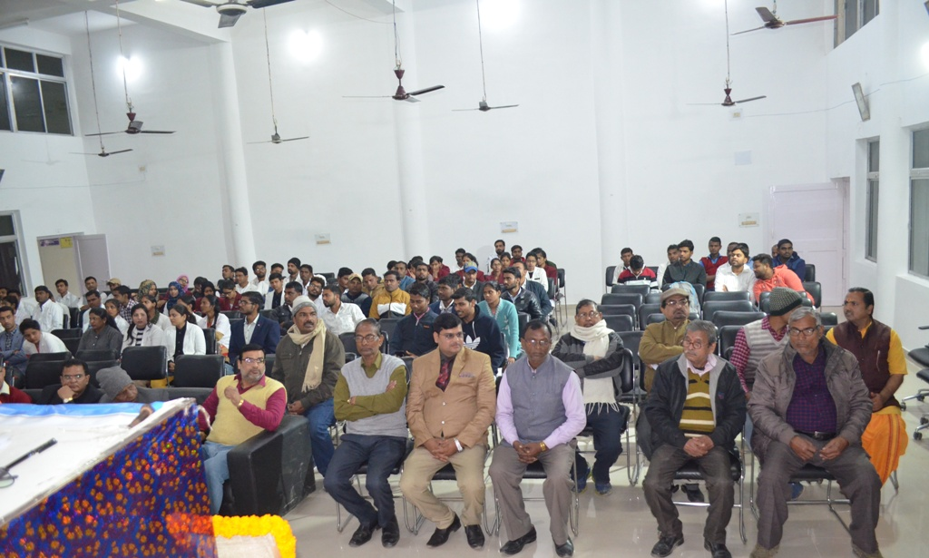
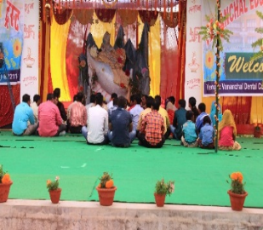
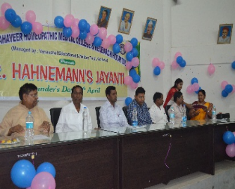
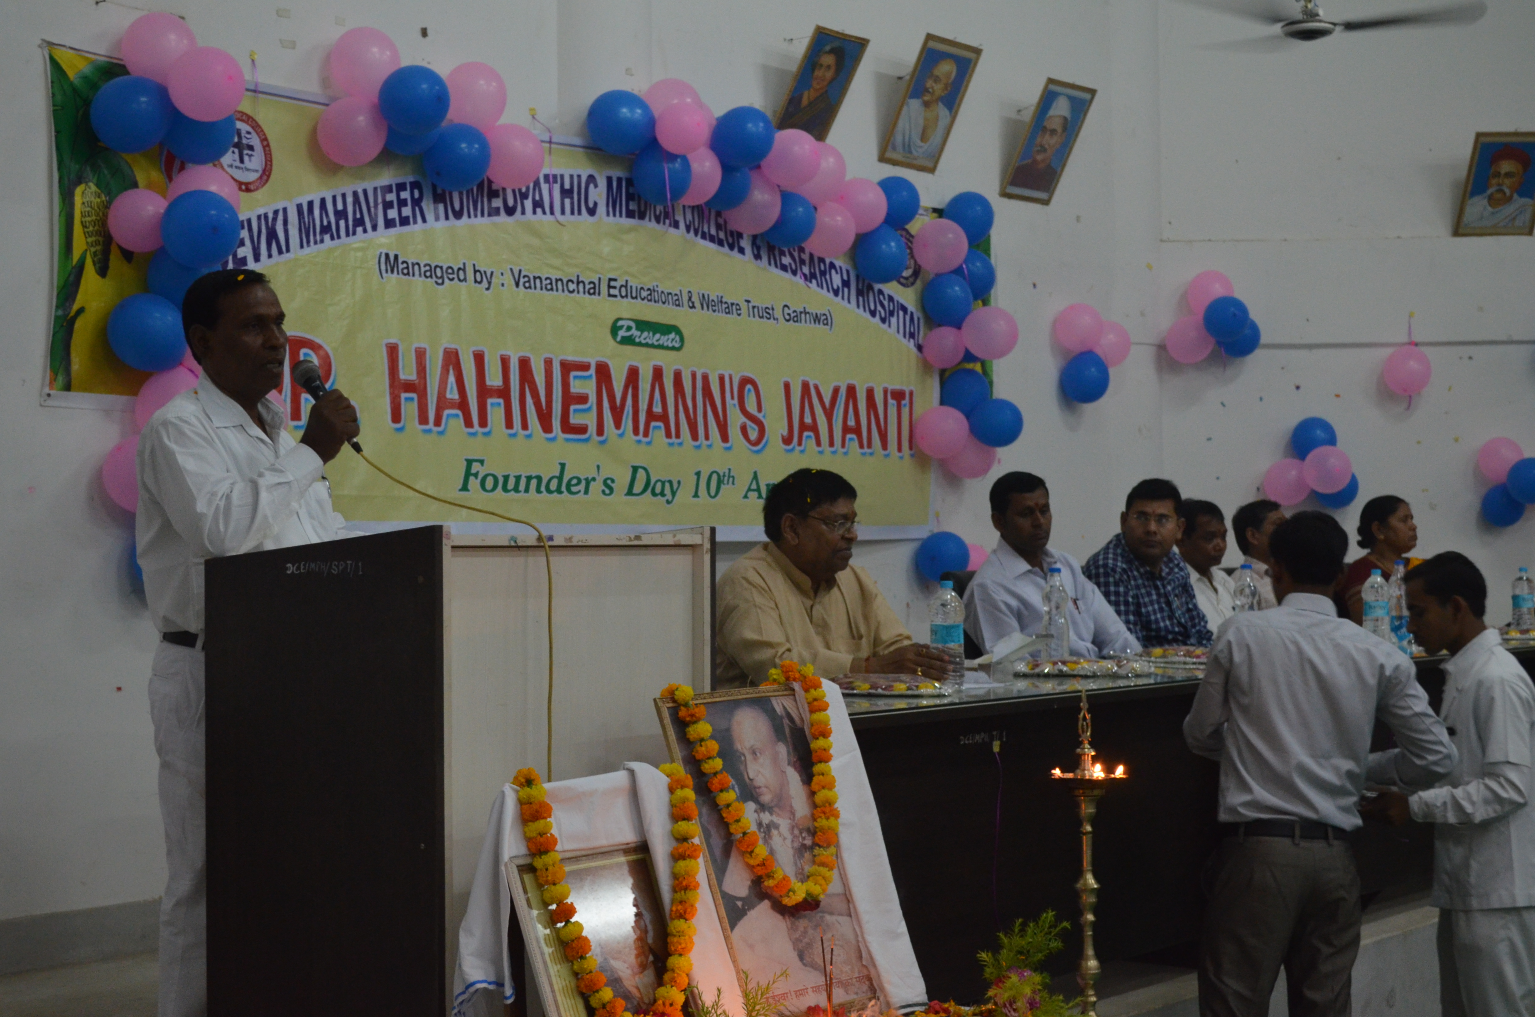
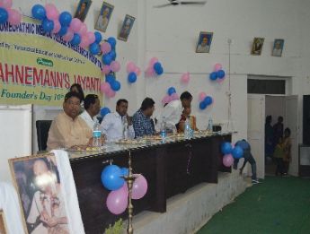
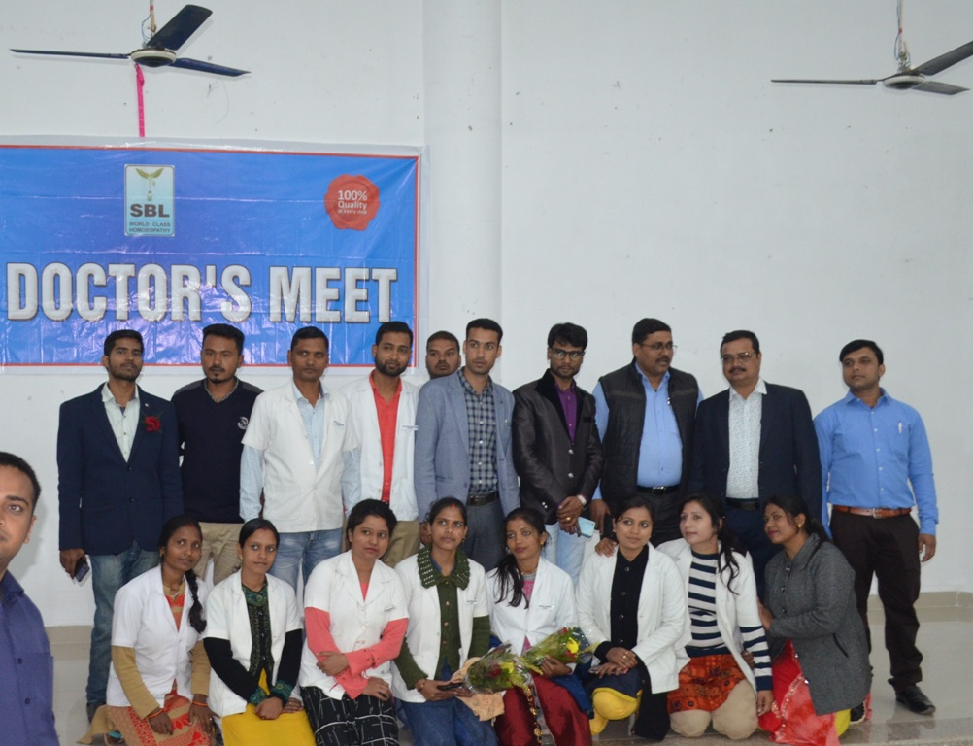
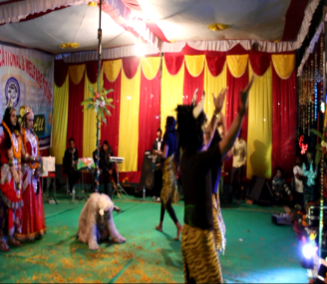
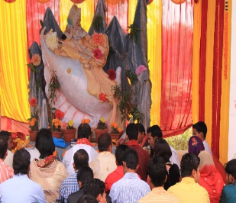
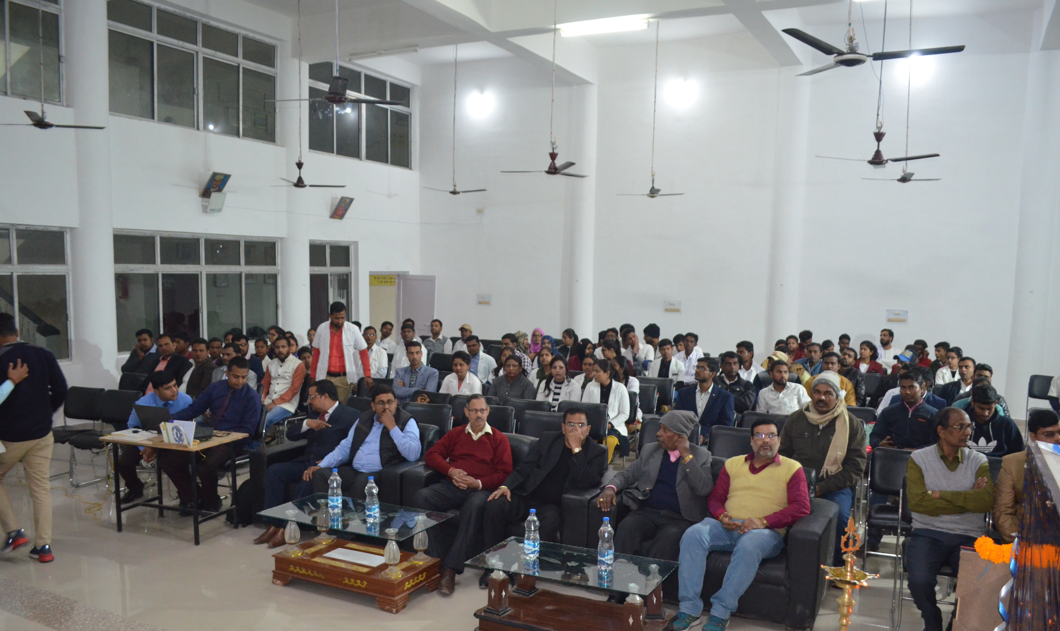
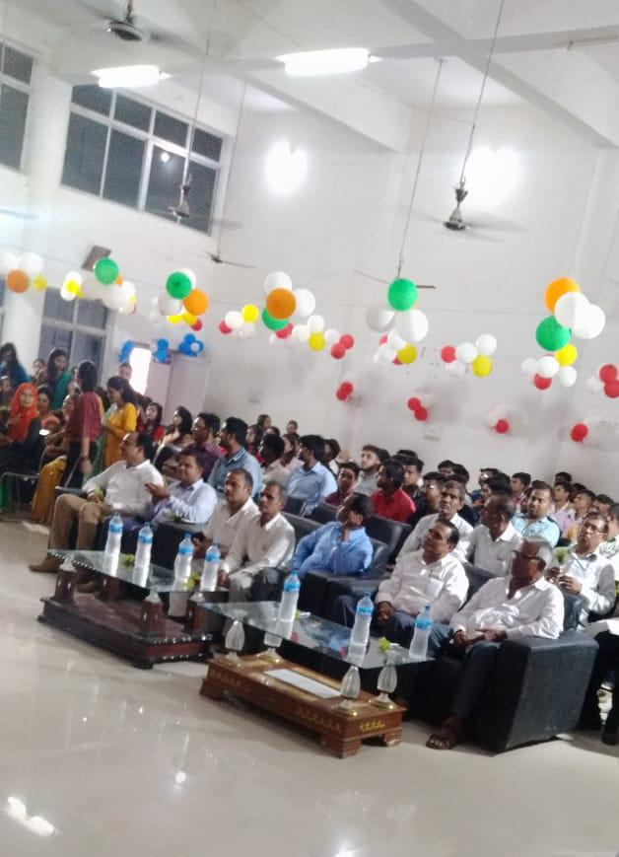
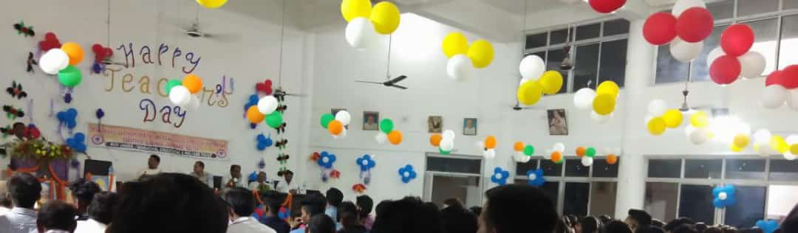
Cultural programmes photos Teacher’s Day, Sarswati Pooja, Hahneman’s Jayanti etc… organized by the institution.

